



L1 Application Monitoring – BRM, BIP and PDC Applications

ITC Apollo B2B MVP Project

Document Name | L1 Application Monitoring
Document Status
Current Version | 1.0
Effective Date
Owner Department & Administrator(s)
Prepared by | Deepak Garg
Reviewed and Approved by

Document Control

Revision History

Version No | Release Date | Prepared by | Reviewed By | Review Comments | Approved by
1.0 |  | Deepak Garg

Contents
1 Introduction 4
1.1 Purpose 4
2 Billing Care Application Access 5
2.1 Logging into Application 5
2.2 Logout………………………………………………………………………………………………………………………………………..6
3 PDC Application Launch 7
3.1 Logging into Application 7
3.1 Logout……………………………………………………………………………………………………………………………………….9
4 BIP Application Launch 10
4.1 Logging into Application 10
4.2 Logout 12
5 BOC Application Launch 13
5.1 Logging into Application 13
5.2 Logout 14
6 Server Health Check……………………………………………………………………………….15

7 BRM Application Processes……………………………………………………………………….18

8 PDC Application Processes ……………………………………………………………………….22

9 BIP Application Processes ………………………………………………………………………...23

10 BRM Database Connectivity .……………………………………………………………………..25

11 PDC Database Connectivity ……………………………………………………………………....27

Introduction

This Monitoring of Application status guide provides information for the user to check availability and status of GUI based BRM, PDC and BIP Applications.

Purpose

The purpose of this document is to give step-by-step information about various ways of monitoring BRM, PDC and BIP Applications status from Frontend and Backend.

BRM Application Access

Billing Care Application Launch
Launch the application and Sign in with provided credentials.
URL: http://172.31.22.22:7011/bc/index.html#

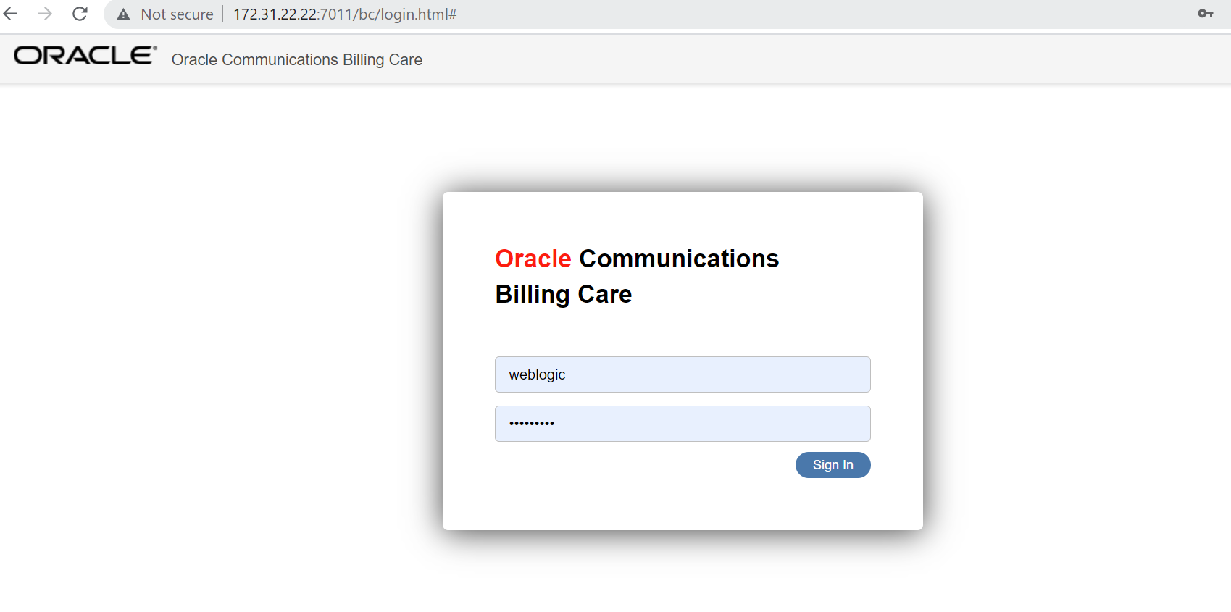
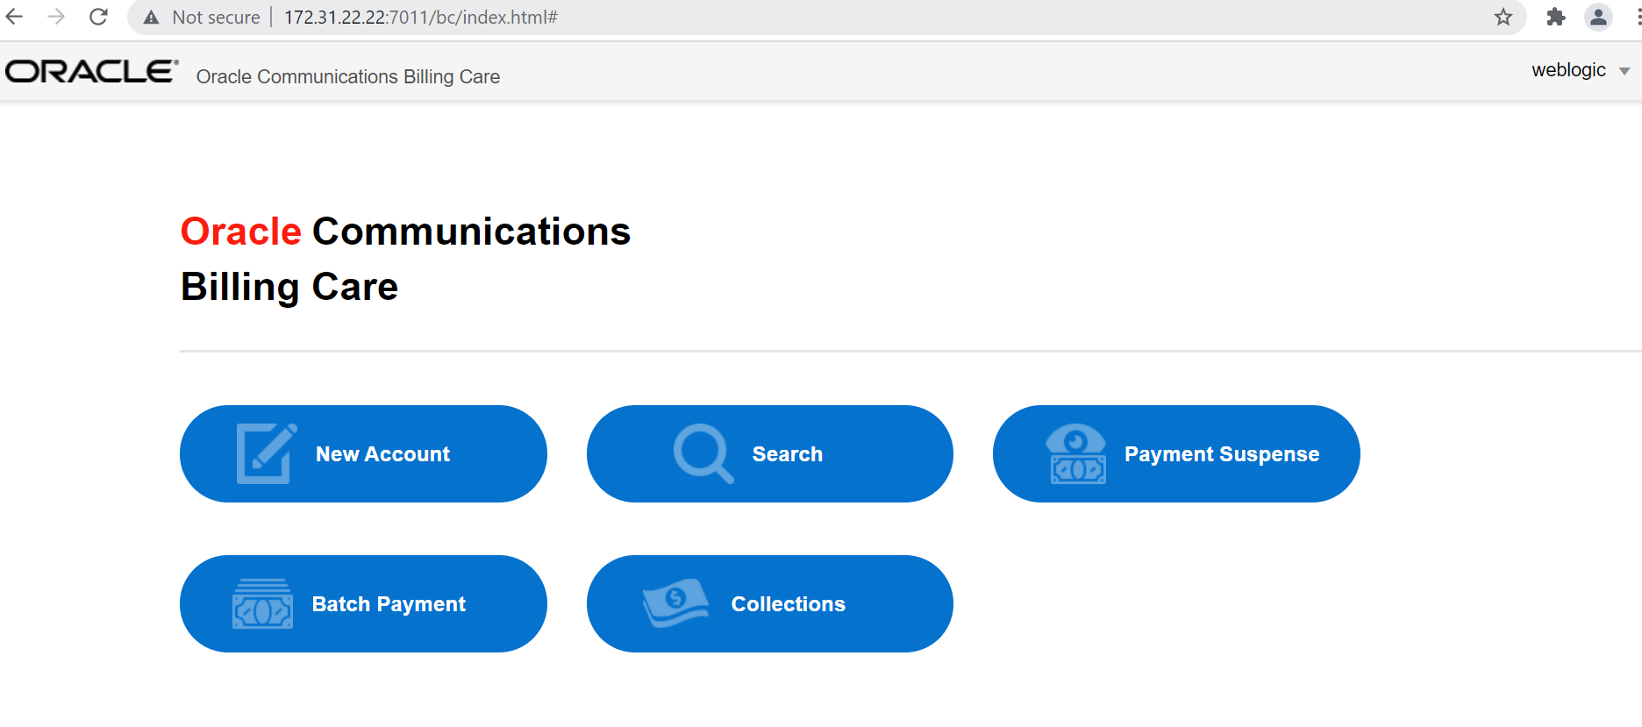

Log out the application from top right and click on Weblogic button and logout.

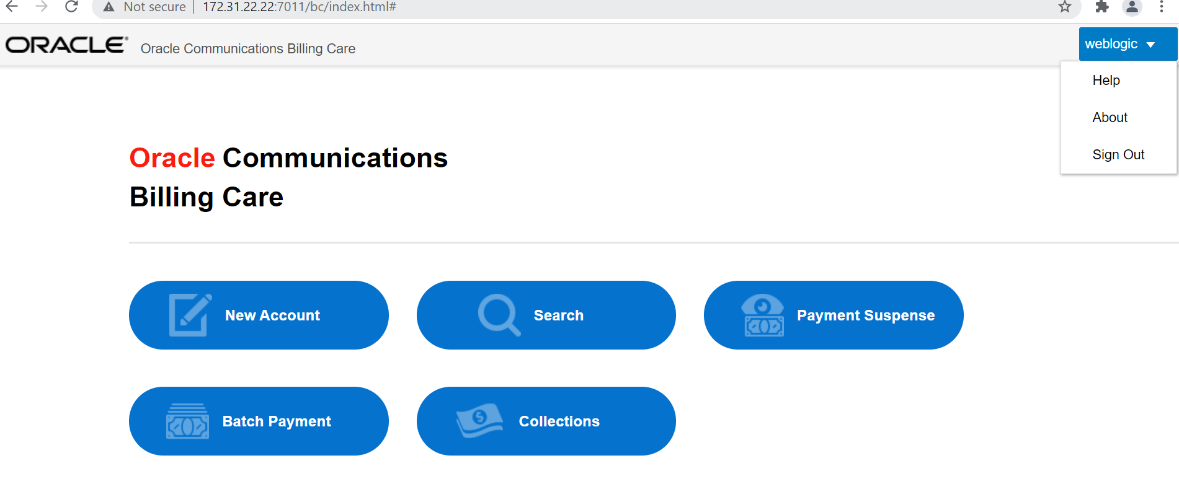

PDC Server Status Check

Logging into Application
Launch the application and Sign in with provided credentials.
URL: https://172.31.22.26:8001/pdc/faces/PricingDesignCenter

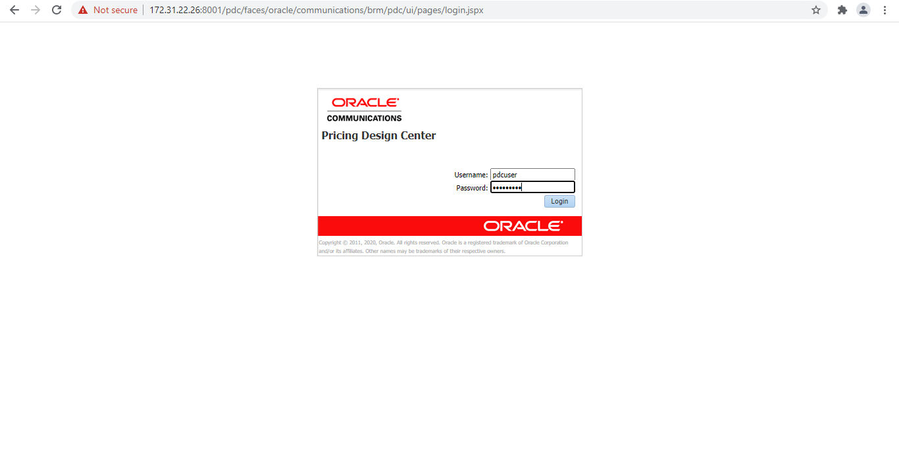
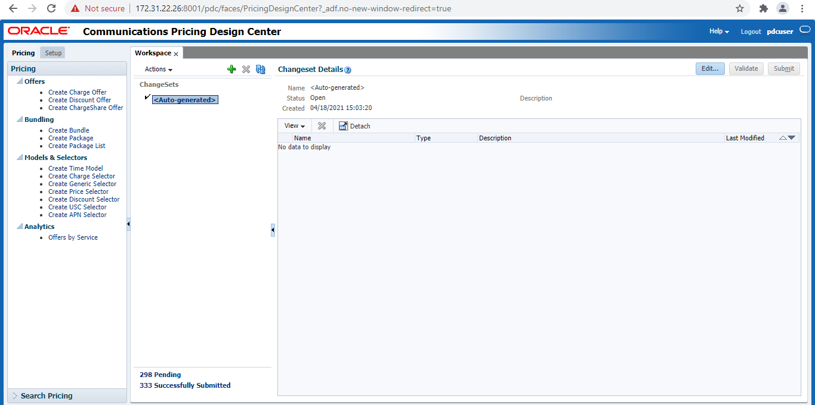

Log out the application from top right and click on logout button.

BIP Server Status Check

Logging into Application
Launch the application and Sign in with provided credentials.
URL: http://172.31.22.33:8003/xmlpserver/

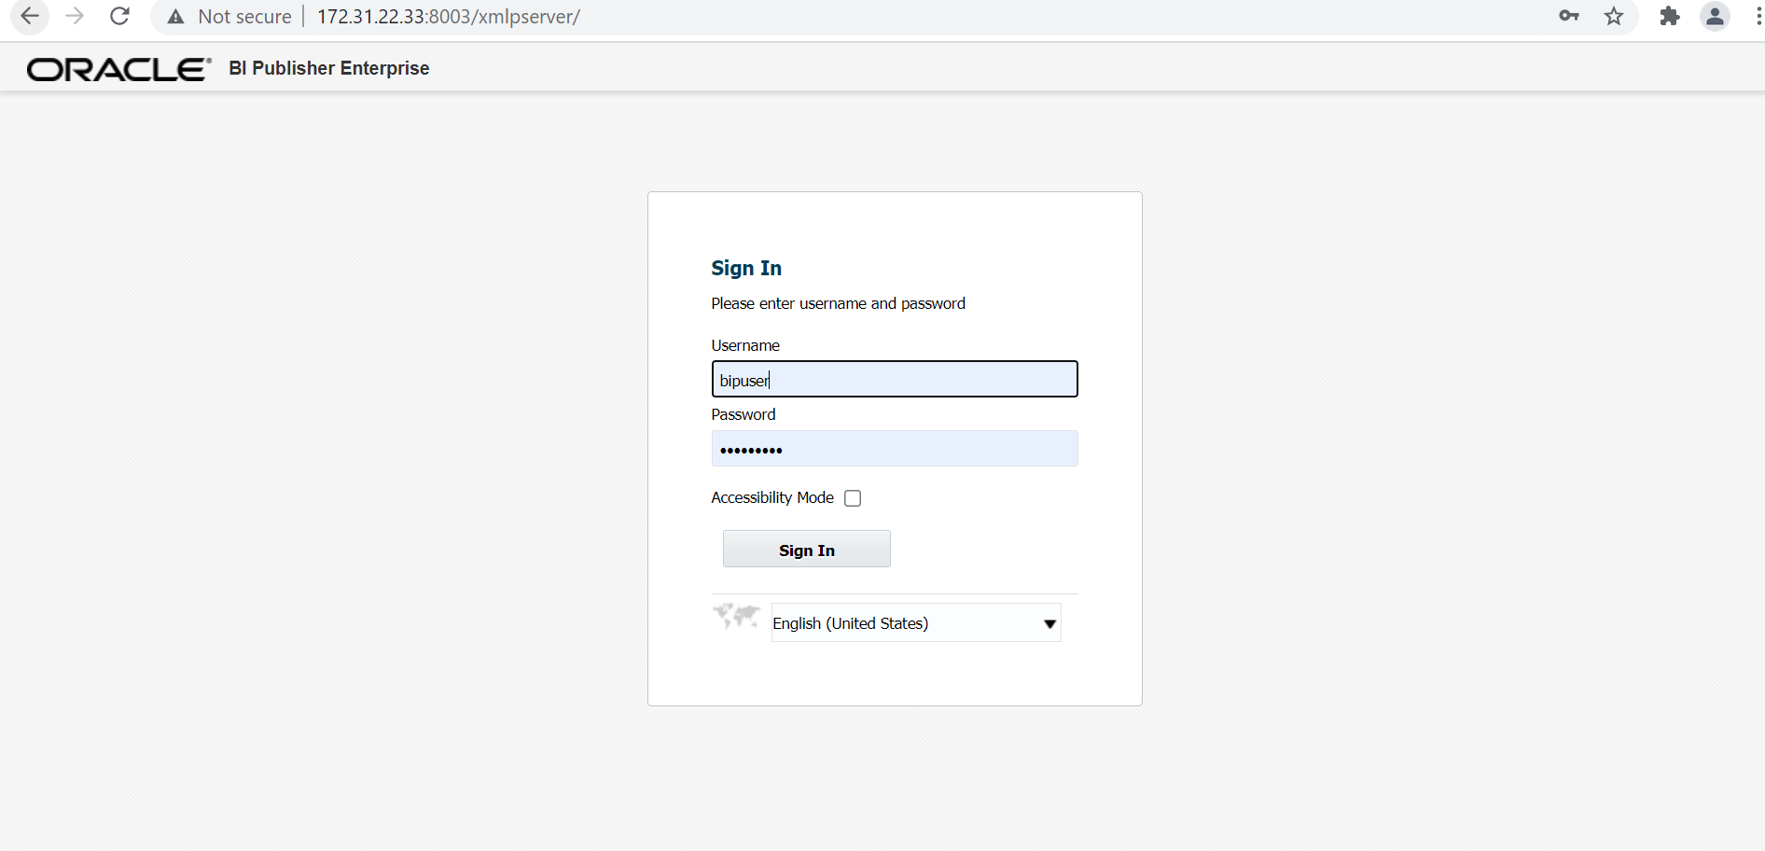

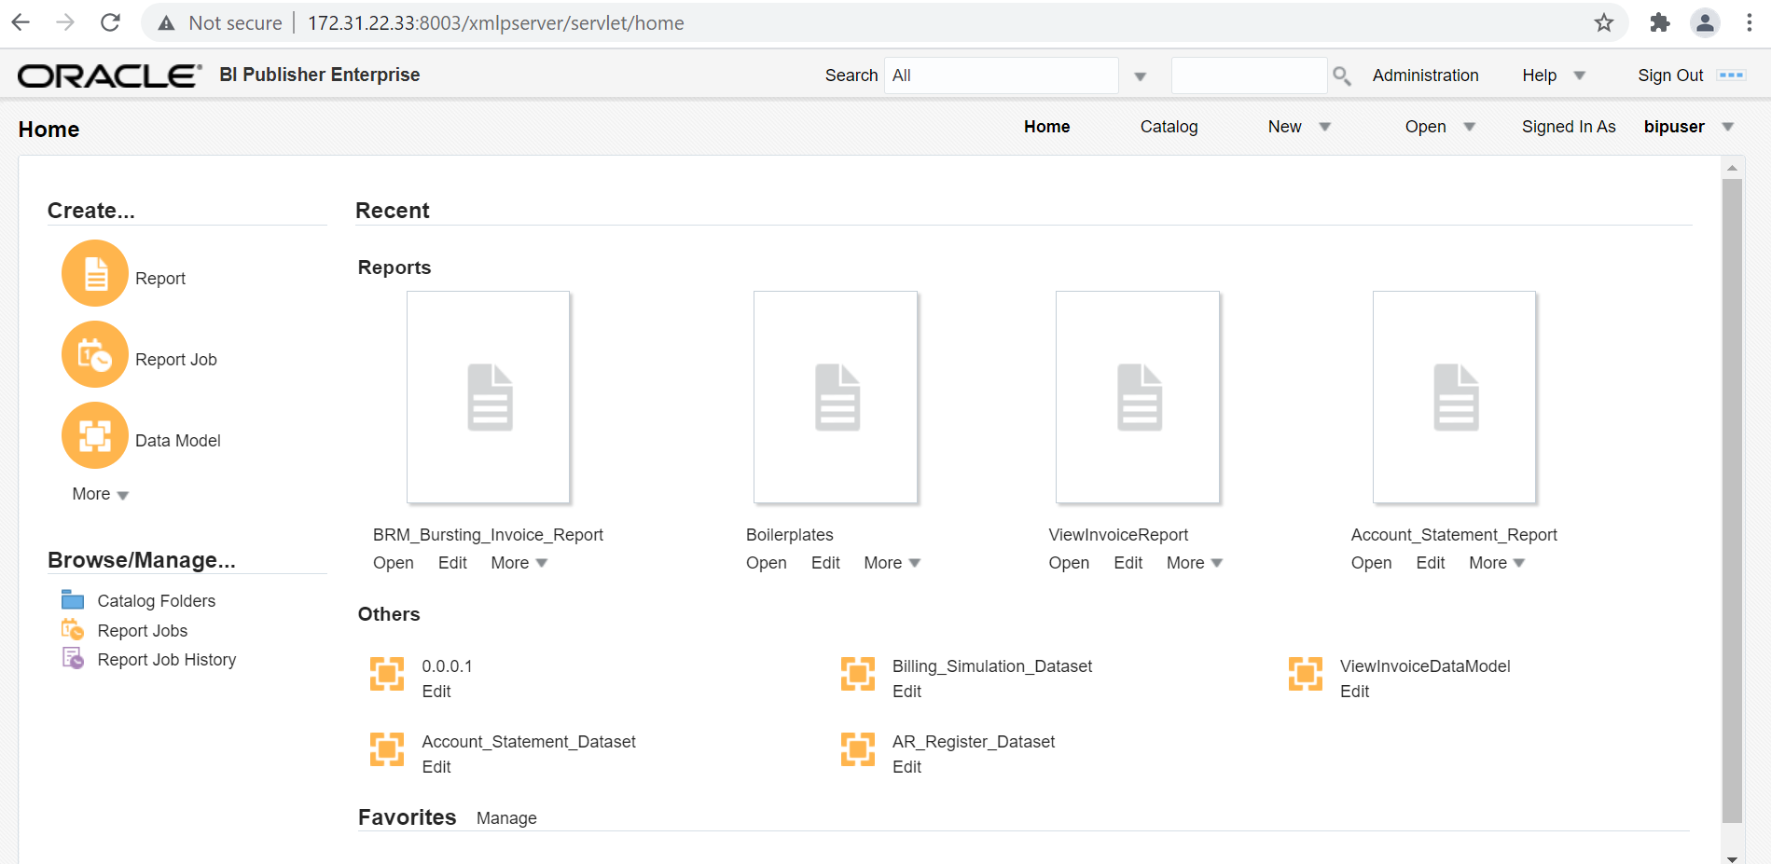

Log out the application from top right and click on ‘Sign Out’ button.

BOC Server Status Check

Logging into Application
Launch the application and Sign in with provided credentials.
URL: http://172.31.22.22:8001/opsdashboard/login.html

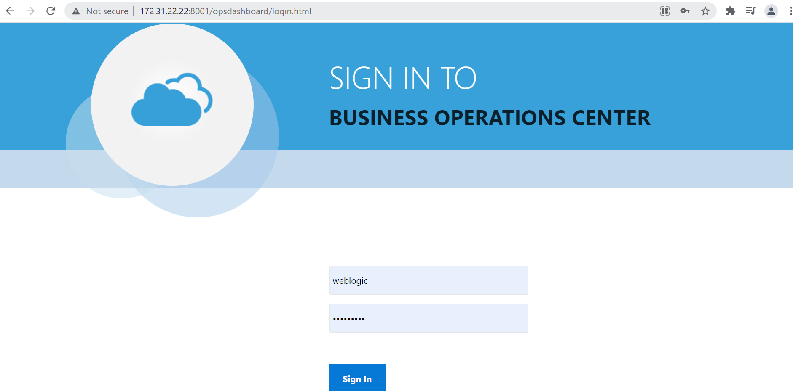

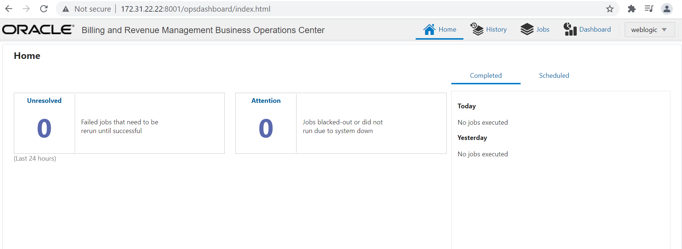

Log out the application from top right and click on weblogic button.

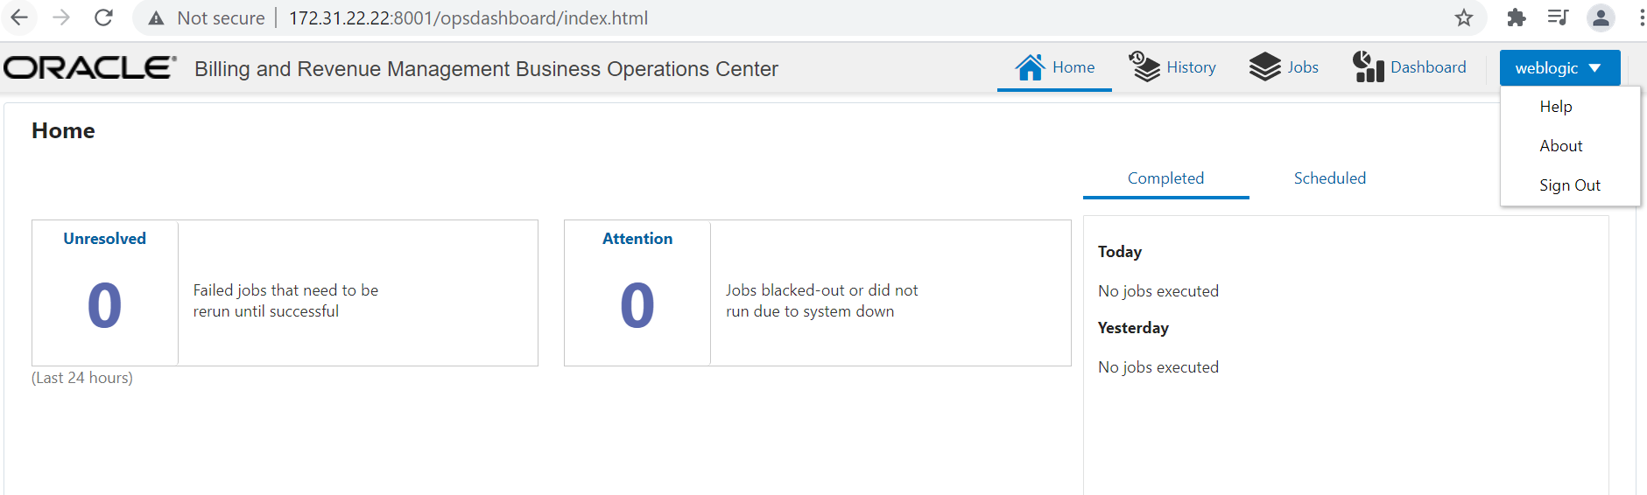

Server health check

Log into the BRM Server ‘172.31.22.22’.

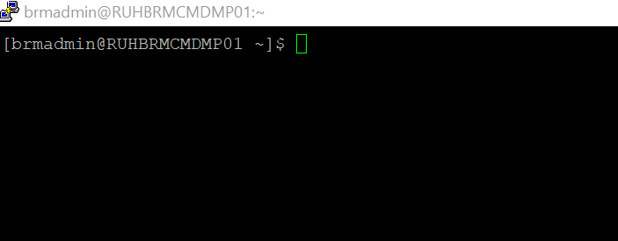

Now run the script ‘ITC-HEALTH-CHECK-SCRIPT.sh’ from the path ‘/backup/health_check’.

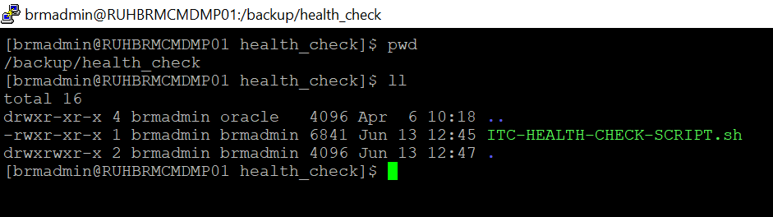

This will create a ‘.txt’ file which contains the server disk space and other memory consumption details.

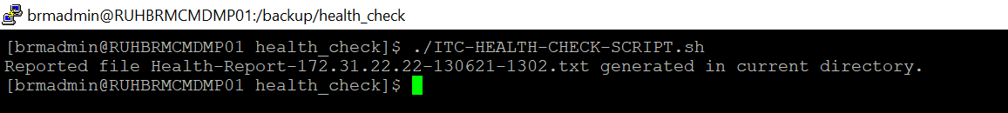

Log into the BRM Server ‘172.31.22.26’.

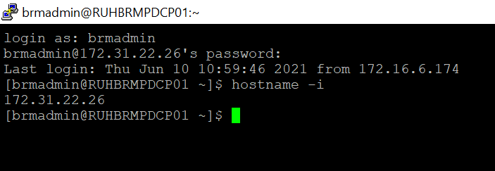

Now run the script ‘ITC-HEALTH-CHECK-SCRIPT.sh’ from the path ‘/backup/health_check’.

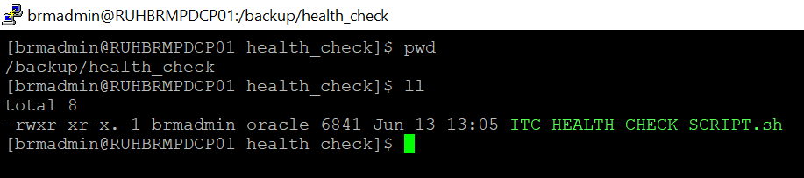

This will create a ‘.txt’ file which contains the server disk space and other memory consumption details.

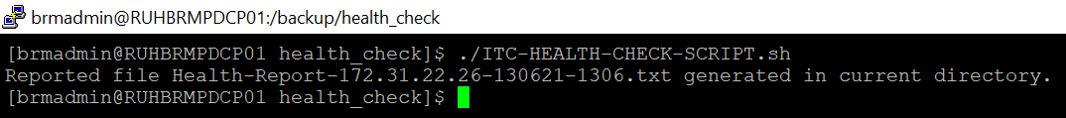

Log into the BRM Server ‘172.31.22.33’.

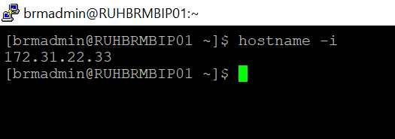

Now run the script ‘ITC-HEALTH-CHECK-SCRIPT.sh’ from the path ‘/backup/health_check’.

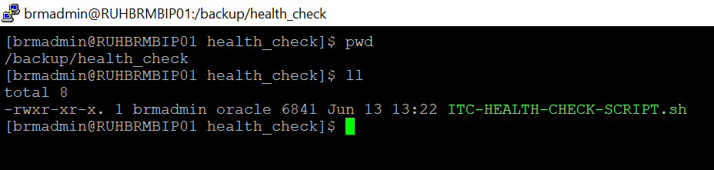

This will create a ‘.txt’ file which contains the server disk space and other memory consumption details.

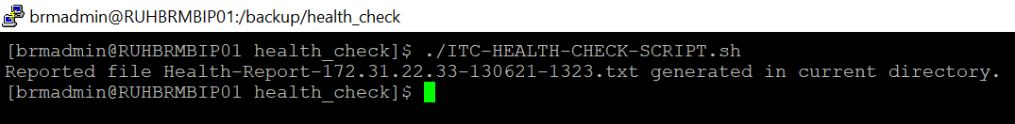

BRM Applications Processes

Log into the server ‘172.31.22.22’.

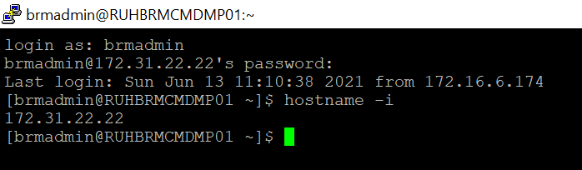

To check for Billing Care’s Weblogic process use the command ‘ps -ef | grep weblogic’
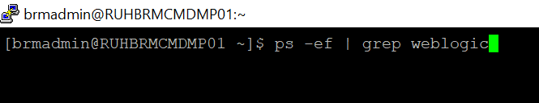

The below process must be running for Billing Care to be up and running.

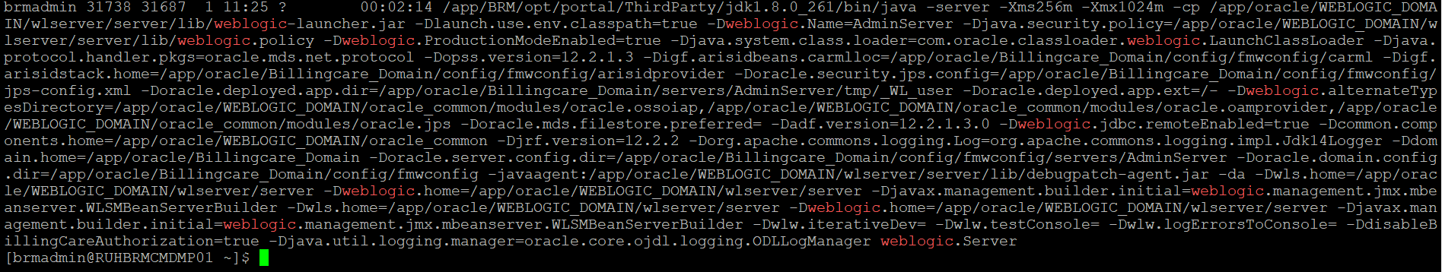

To check for BOC’s Weblogic process use the command ‘ps -ef | grep weblogic’

The below process must be running for BOC to be up and running.

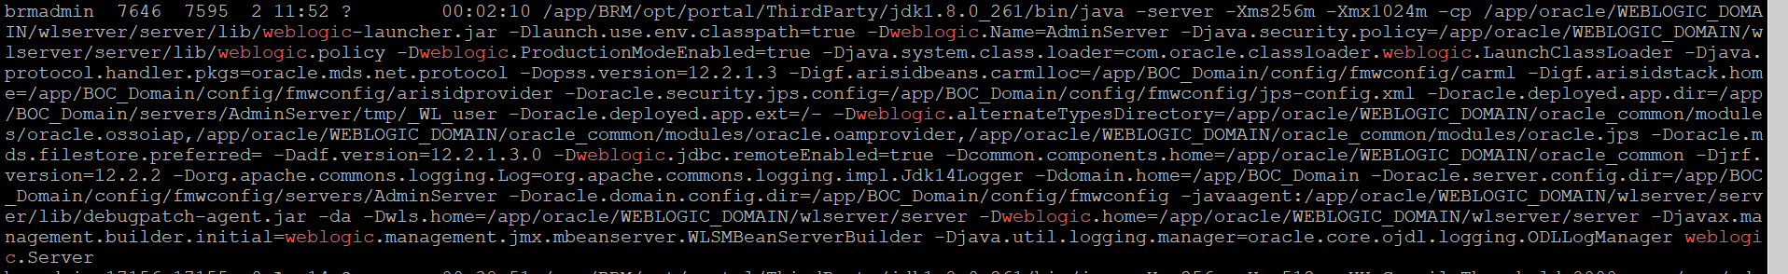

To check for ‘cm’ process use the command ps –ef | grep cm$

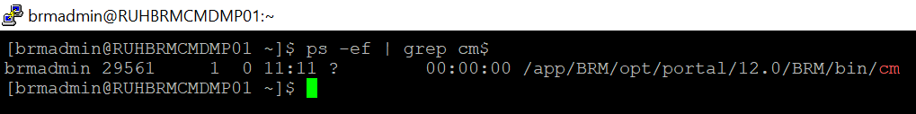

To check for ‘dm_oracle’ process use the command ps –ef | grep dm_oracle

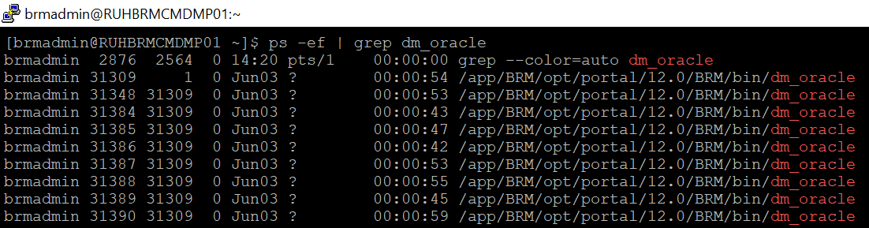

To check for ‘eai_js’ process use the command ps –ef | grep eai_js

To check for ‘dm_aq’ process use the command ps –ef | grep dm_aq

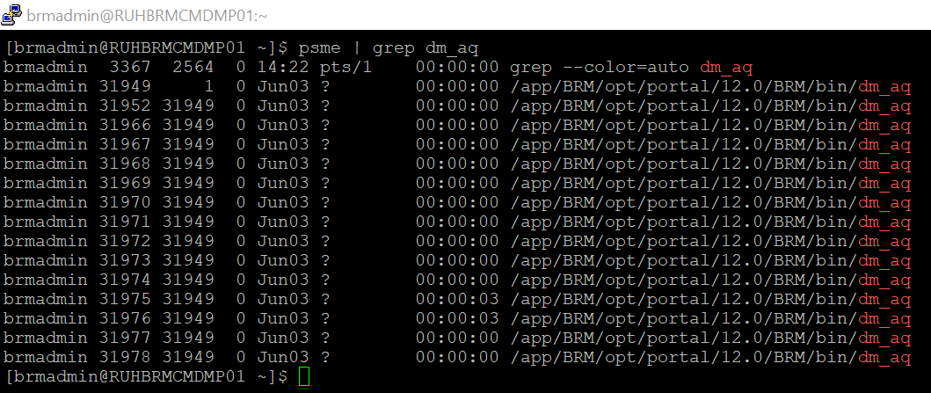

To check for ‘dm_ifw’ process use the command ps –ef | grep dm_ifw_sync

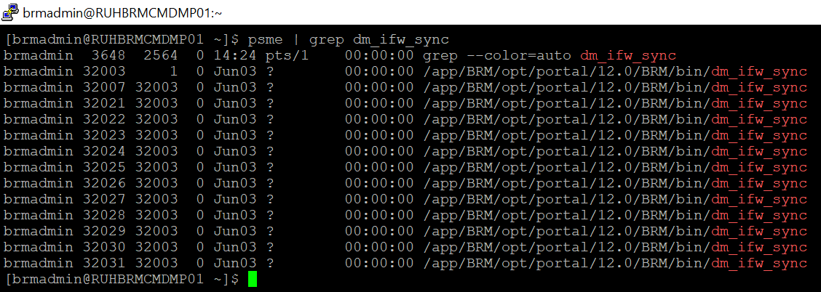

To check for ‘RRETransformationEngine’ process use the command ps –ef | grep RRETransformationEngine

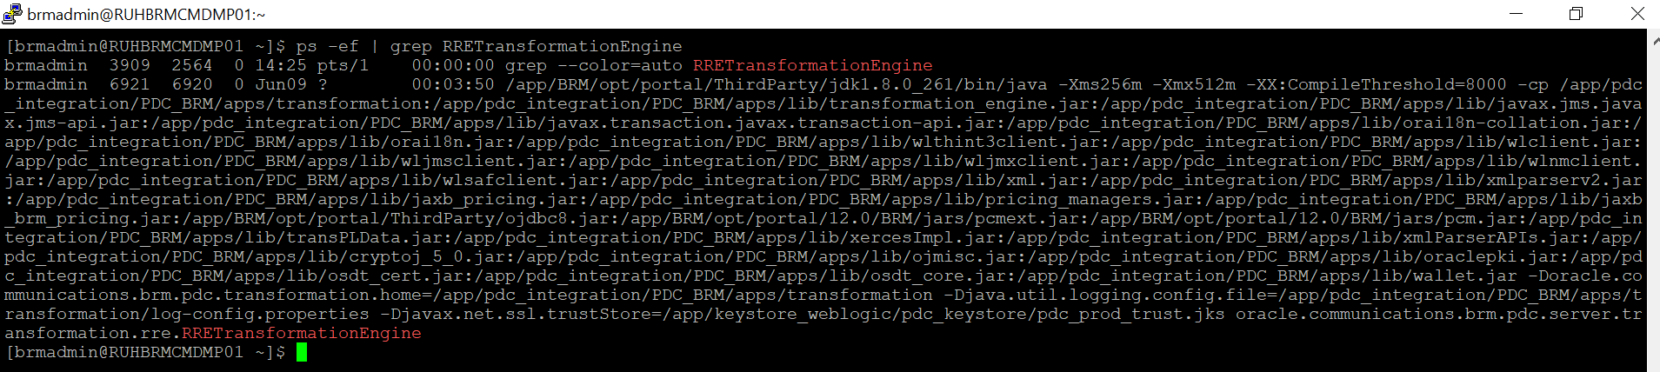

To check for ‘BRETransformationEngine’ process use the command ps –ef | grep BRETransformationEngine

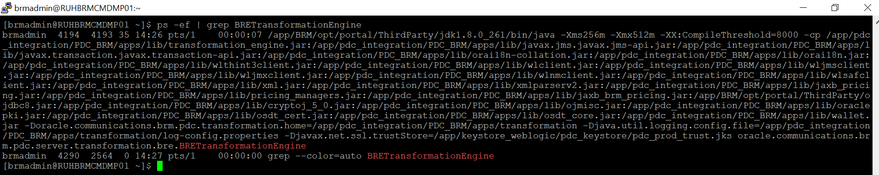

FOR STARTING AND STOPPING OF SERVICES

stop_dm_oracle | start_dm_oracle
stop_cm | start_cm
stop_dm_ifw_sync | start_dm_ifw_sync
stop_eai_js | start_eai_js
stop_dm_aq | start_dm_aq
stop_dm_email | start_dm_email

startup script : nohup ./startWebLogic.sh &
stopping : ./stopWebLogic.sh
To check : ps -ef | grep weblogic

1.BOC-PROD

PATH : /app/BOC_Domain/bin
LOGS PATH : /app/BOC_Domain/servers/AdminServer/logs

2.BILLING CARE-PROD

PATH : /app/oracle/Billingcare_Domain/bin
LOGS PATH : /app/oracle/Billingcare_Domain/servers/AdminServer/logs

PDC-BRM INTERGRATION SERVICES

PATH : /app/pdc_integration/PDC_BRM/apps/bin

STARTUP SCRIPT

- nohup ./startRRETransformer < password &
- nohup ./startBRETransformer< password &
- nohup ./startSyncPDC< password &
tail -f nohup.out

STOP :
- ./stopBRETransformer
- ./ stopRRETransformer
- ./ stopSyncPDC

PDC Application Process

Log into the server ‘172.31.22.26’.

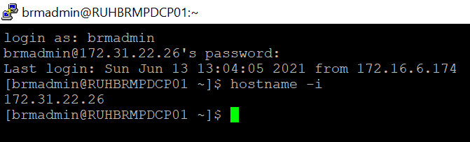

To check for PDC’s Weblogic process use the command ‘ps -ef | grep weblogic’

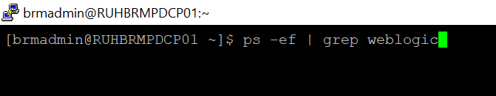

The below process must be running for PDC to be up and running.

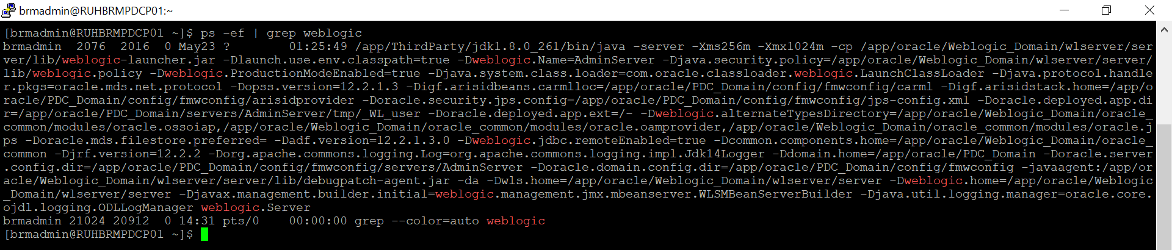

For start and Stop

SCRIPT PATH : /app/oracle/PDC_Domain/bin

Startup Scripts : nohup ./startWebLogic.sh &
STOPPING : ./stopWebLogic.sh

LOGS : /app/oracle/PDC_Domain/servers/AdminServer/logs
BIP Application Process

Log into the server ‘172.31.22.33’.

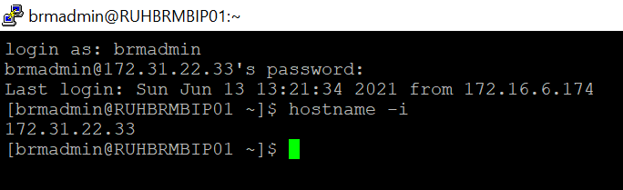

To check for BIP’s Weblogic process use the command ‘ps -ef | grep weblogic’

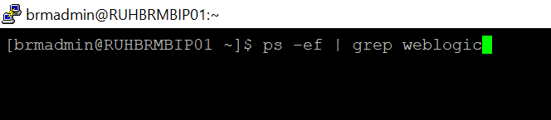

The below process must be running for PDC to be up and running.

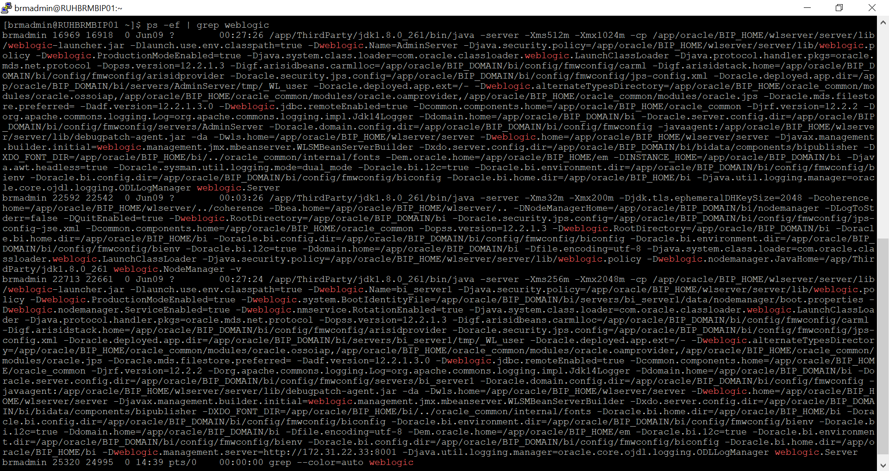

SCRIPT:

ADMIN SERVER
- nohup ./startWebLogic.sh &
tail -f nohup.out (for checking running process logs)
- ./stopweblogic.sh
MANAGE SERVER
- ./start.sh
- ./stop.sh

Scripts PATH
- Admin server PATH : app/BIP_DOMAIN/bi/bin
- MANAGE SERVER PATH: /app/BIP_DOMAIN/bi/bitools/bin

LOGS -
- Admin server PATH : app/BIP_DOMAIN/bi/servers/AdminServer/logs
- MANAGE SERVER PATH : /app/BIP_DOMAIN/bi/servers/bi_server1/logs

BRM Database Connectivity

Open the SQl Developer and make a new connection with below details.

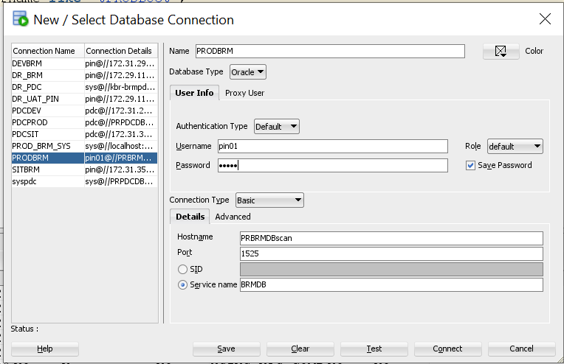

Click on ‘Test’ button to check the DB connectivity. The status should be success.

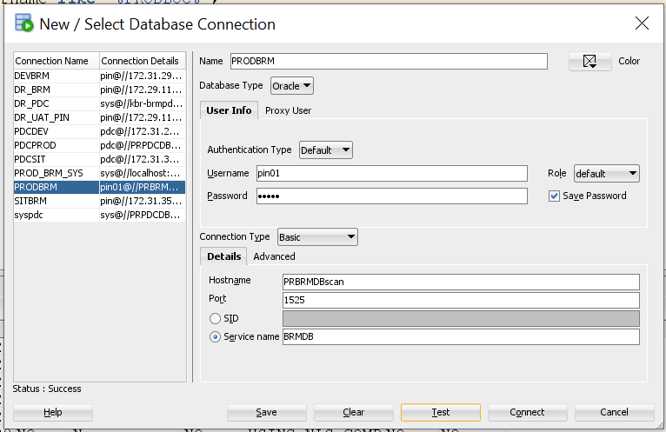

PDC Database Connectivity

Open the SQl Developer and make a new connection with below details.

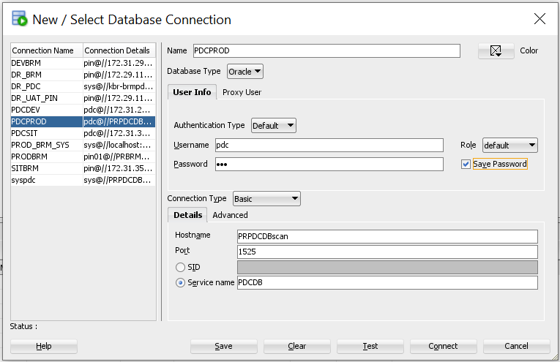

Click on ‘Test’ button to check the DB connectivity. The status should be success.

